Topic 2
Lab Experiments

1. Selection Sort

Question 1: Trophy Ranking System
Aim:
To extract the top 5 highest scores using Selection Sort.
Algorithm:
- Read the list of scores.
- Find the maximum score in the unsorted portion.
- Swap it with the current position.
- Repeat for the first 5 positions.
- Display the top 5 scores.

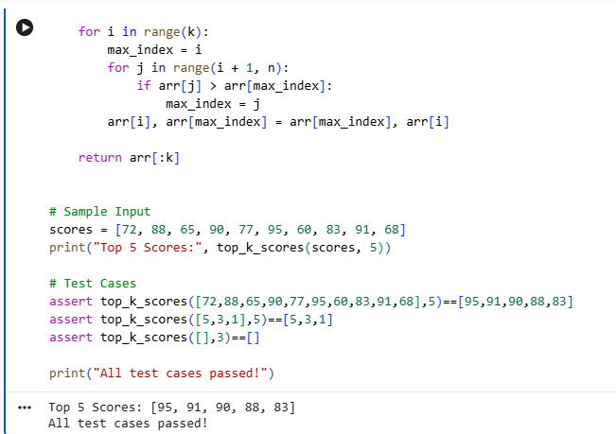
Time Complexity: O(k × n) (where k = 5)
Result:
The top 5 scores were successfully extracted using Selection Sort.

Question 2: Memory-Constrained Embedded Device
Aim:
To sort temperature readings with minimum write operations using Selection Sort.
Algorithm:
- Read the temperature values.
- Find the minimum element.
- Swap only if required.
- Count the number of swaps.
- Display the sorted list and swap count.

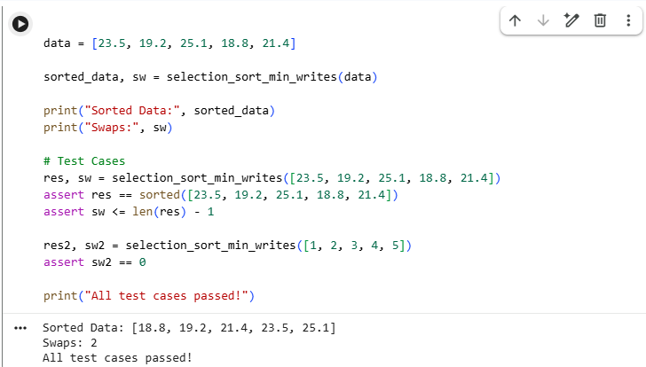
Time Complexity: O(n²)
Result:
The readings were sorted successfully with at most n−1 swaps.

Question 3: Library Book Reordering
Aim:
To reorder books by ID using Selection Sort while minimizing physical moves.
Algorithm:
- Read book IDs.
- Find the minimum ID.
- Swap if necessary.
- Count each physical swap.
- Display sorted IDs and move count.

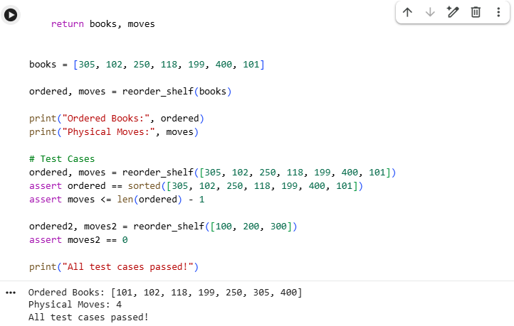
Time Complexity: O(n²)
Result:
The books were arranged in ascending order with minimum physical moves.

Question 4: Contest Prize Distribution
Aim:
To rank participants in descending order using Selection Sort.
Algorithm:
- Read participant names and scores.
- Find the highest score.
- Swap it to the current position.
- Repeat until all participants are ranked.
- Display the ranking.

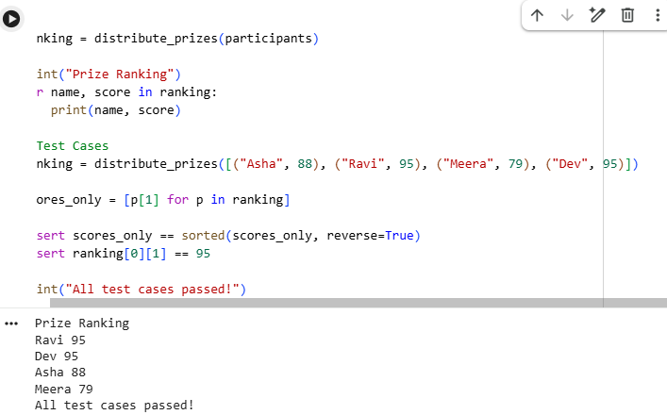
Time Complexity: O(n²)
Result:
Participants were ranked correctly in descending order.

Question 5: Small Dataset in a Mobile App
Aim:
To sort a small list of recently viewed items using Selection Sort.
Algorithm:
- Read the item prices.
- Find the minimum value.
- Swap it to the correct position.
- Repeat until sorted.
- Display the sorted list.

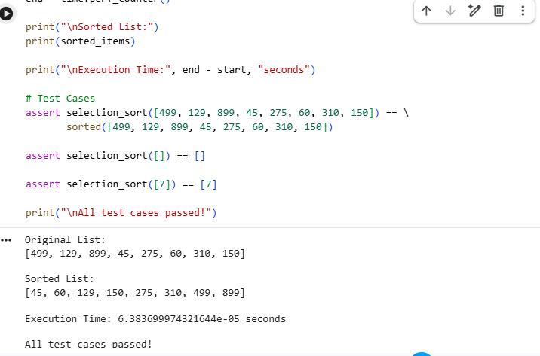
Time Complexity: O(n²)
Result:
The small dataset was sorted successfully.

2. Bubble Sort

Question 1: Exam Result Slip Correction
Aim:
To sort a nearly sorted list using Optimized Bubble Sort.
Algorithm:
- Read the roll numbers.
- Compare adjacent elements.
- Swap if necessary.
- Use a swapped flag.
- Stop if no swaps occur.

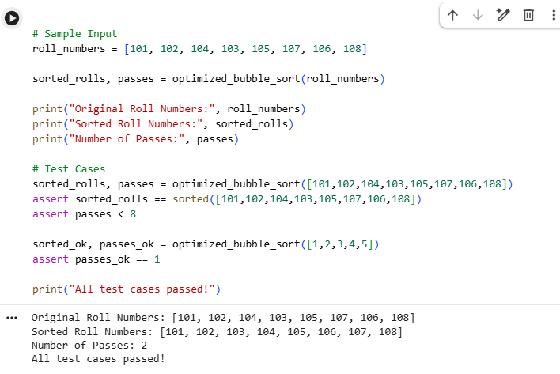
Time Complexity: Best: O(n), Worst: O(n²)
Result:
The roll numbers were sorted successfully with fewer passes.

Question 2: Traffic Signal Priority Queue
Aim:
To arrange vehicles according to priority using Bubble Sort.
Algorithm:
- Read the vehicle queue.
- Assign priority values.
- Compare adjacent priorities.
- Swap if required.
- Display the sorted queue.

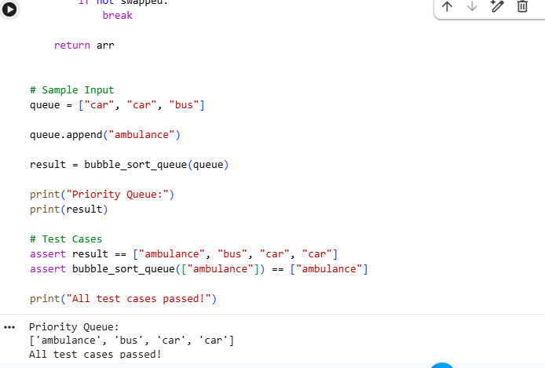
Time Complexity: O(n²)
Result:
Vehicles were arranged according to priority.

Question 3: Bubble Sort Visualization Tool
Aim:
To demonstrate Bubble Sort by displaying the array after every pass.
Algorithm:
- Read the array.
- Perform Bubble Sort.
- Store the array after every pass.
- Display each pass.
- Display the final sorted array.

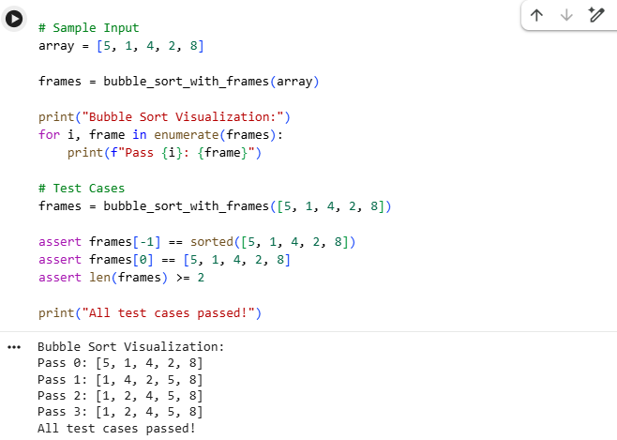
Time Complexity: O(n²)
Result:
The sorting process was displayed successfully after every pass.

Question 4: Sorting Sensor Alerts by Severity
Aim:
To compare normal and optimized Bubble Sort.
Algorithm:
- Read alert levels.
- Apply normal Bubble Sort.
- Apply optimized Bubble Sort.
- Compare the number of comparisons.
- Display results.

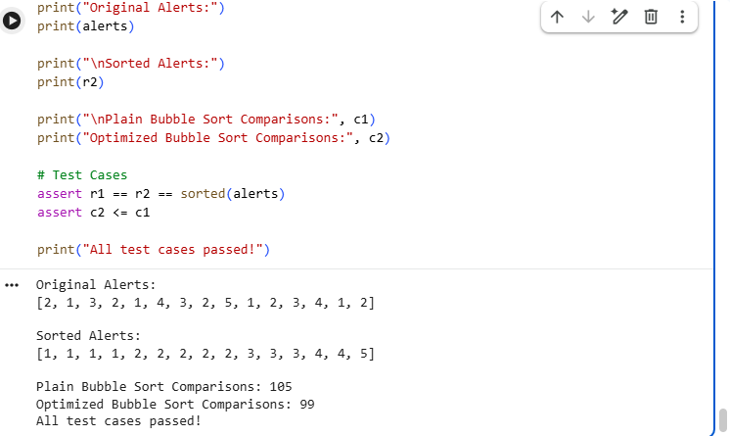
Time Complexity: Best: O(n), Worst: O(n²)
Result:
Optimized Bubble Sort required fewer comparisons for nearly sorted data.

Question 5: Card Game Hand Sorting
Aim:
To sort a nearly sorted hand of cards using Bubble Sort.
Algorithm:
- Read the card values.
- Add the new card.
- Compare adjacent cards.
- Swap if required.
- Display the sorted hand.

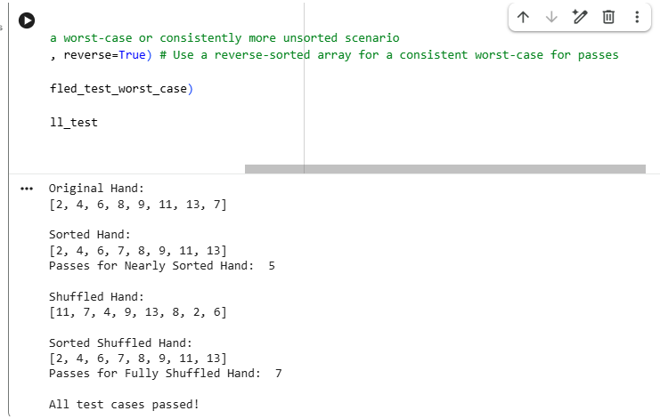
Time Complexity: Best: O(n), Worst: O(n²)
Result:
The cards were sorted successfully with fewer passes.

3. Insertion Sort

Question 1: Live Leaderboard Updates
Aim:
To insert an updated score into an already sorted leaderboard.
Algorithm:
- Read the leaderboard.
- Remove the old score.
- Insert the updated score in its correct position.
- Shift elements as needed.
- Display the updated leaderboard.

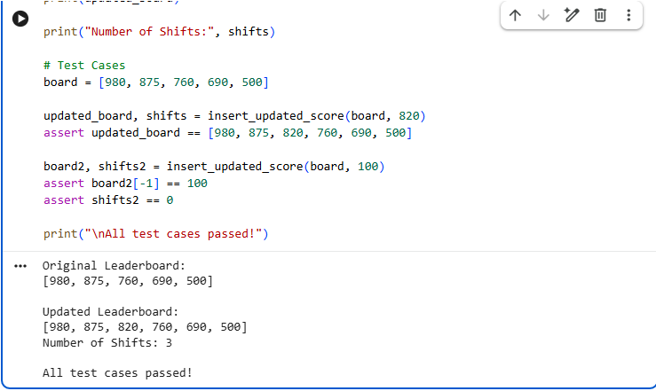
Time Complexity: O(n)
Result:
The leaderboard was updated successfully.

Question 2: Card Sorting While Playing
Aim:
To sort cards one by one using Insertion Sort.
Algorithm:
- Start with an empty hand.
- Pick one card.
- Insert it into the correct position.
- Shift larger cards.
- Repeat until all cards are inserted.

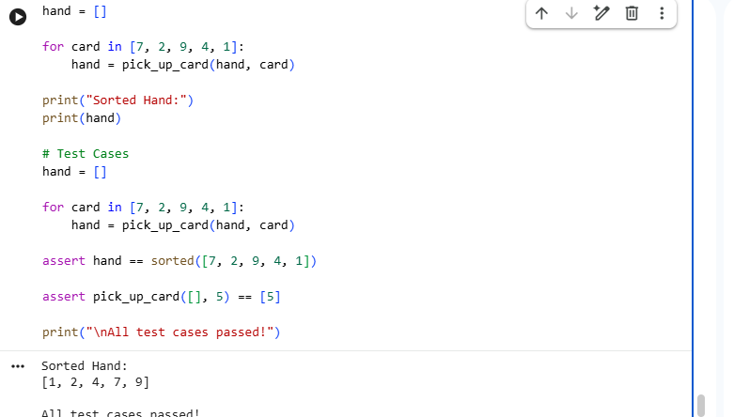
Time Complexity: Overall O(n²)
Result:
The cards were arranged in sorted order successfully.

Question 3: Real-Time Stock Price Feed
Aim:
To maintain a sorted list of stock prices.
Algorithm:
- Read incoming stock prices.
- Find the insertion position.
- Shift elements.
- Insert the new price.
- Display the updated list.
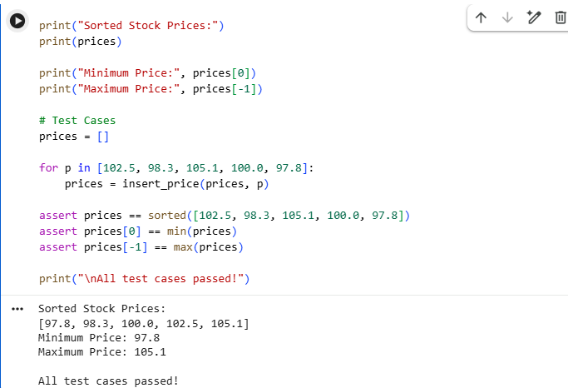
Time Complexity: O(n) per insertion
Result:
The stock prices remained sorted after every insertion.

Question 4: Playlist Reordering by Recently Added
Aim:
To insert a newly added song into an already sorted playlist.
Algorithm:
- Read the playlist.
- Add the new song.
- Shift larger durations.
- Insert at the correct position.
- Display the updated playlist.

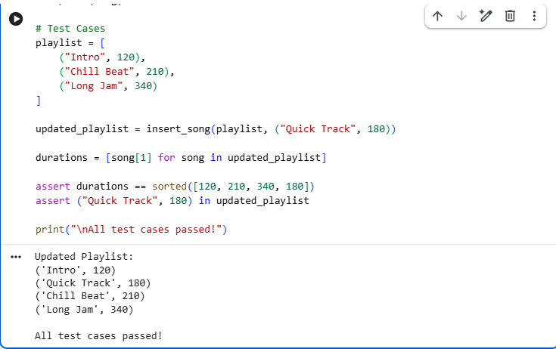
Time Complexity: O(n)
Result:
The playlist was reordered successfully.

Question 5: Nearly Sorted Sensor Log Correction
Aim:
To sort a nearly sorted sensor log using Insertion Sort.
Algorithm:
- Read the sensor log.
- Compare adjacent elements.
- Shift larger values.
- Insert at the correct position.
- Display the sorted log.

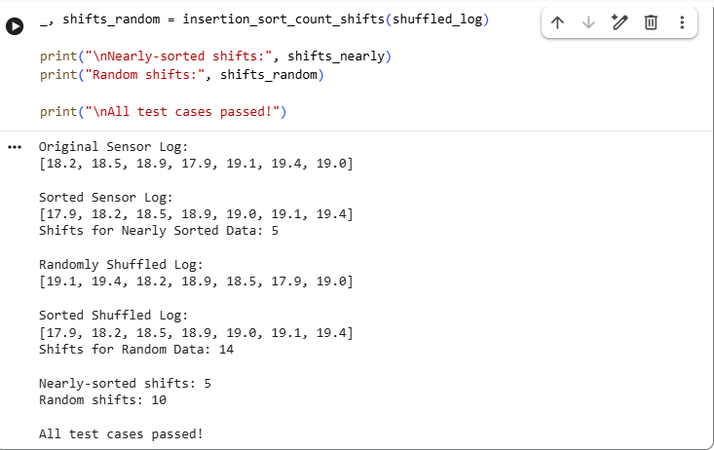
Time Complexity:
- Best Case: O(n)
- Worst Case: O(n²)
Result:
The sensor log was sorted successfully with very few shifts for nearly sorted data.

